Batch: B2 Roll No.: 16010121200

Experiment / assignment / tutorial No. 6

Title: User interface design using UI tools for mini project
______________________________________________________________________
Aim: To enable the students learn different user interface design tools and their aspects
______________________________________________________________________

CO: Prepare the system design and model
______________________________________________________________________

Books/ Journals/ Websites referred:
- Roger Pressman, “Software Engineering”, sixth edition, Tata McGraw Hill.
__________________________________________________________________
Pre Lab/ Prior Concepts:

The user interface Need:
System users often judge a system by its interface rather than its functionality. A poorly designed interface can cause a user to make catastrophic errors. Poor user interface design is the reason why so many software systems are never used. Most users of business systems interact with these systems through graphical interfaces although.
GUI characteristics
Windows Multiple windows allow different information to be displayed simultaneously on the user’s screen. Icons different types of information. On some systems, icons represent files; on others, icons represent processes. Menus Commands are selected from a menu rather than typed in a command language. A pointing device such as a mouse is used for selecting choices from a menu or indicating items of interest in a window.
GUI advantages
They are easy to learn and use.
• Users without experience can learn to use the system quickly
The user may switch quickly from one task to another and can interact with several different applications.
Information remains visible in its own window when attention is switched.
Fast, full-screen interaction is possible with immediate access to anywhere on the
User Interface Design Models
User model — a profile of all end users of the system
Design model — a design realization of the user model
Mental model (system perception) — the user’s mental image of what the interface is
Implementation model — the interface “look and feel” coupled with supporting information that describe interface syntax and semantics
User interface design analysis:
The overall process for analysing and designing a user interface begins with the creation of different models of system function (as perceived from the outside). You begin by delineating the human- and computer-oriented tasks that are required to achieve system function and then considering the design issues that apply to all interface designs. Tools are used to prototype and ultimately implement the design model, and the result is evaluated by end users for quality.

USER MODEL:
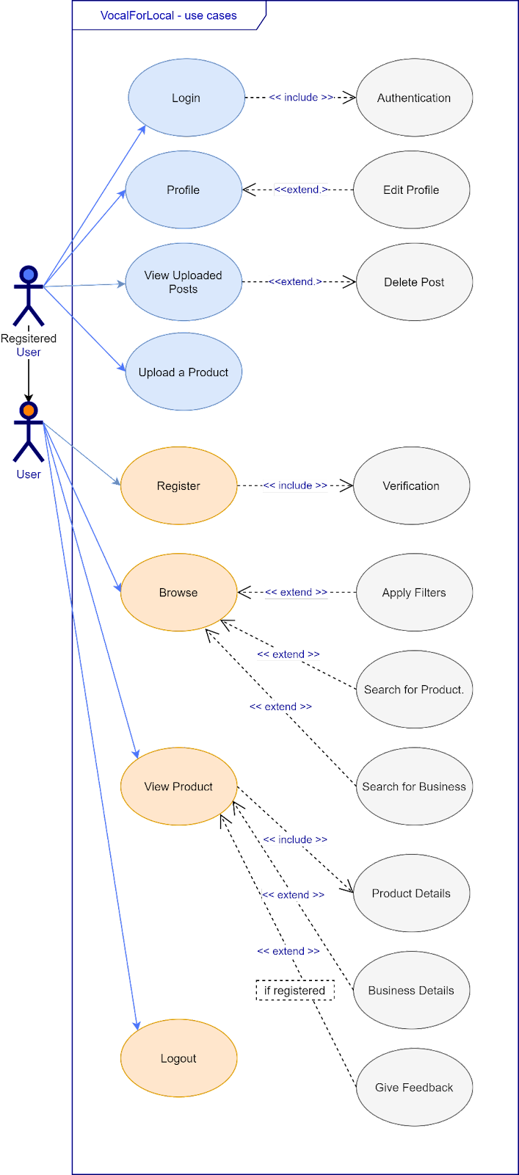

Design Model:
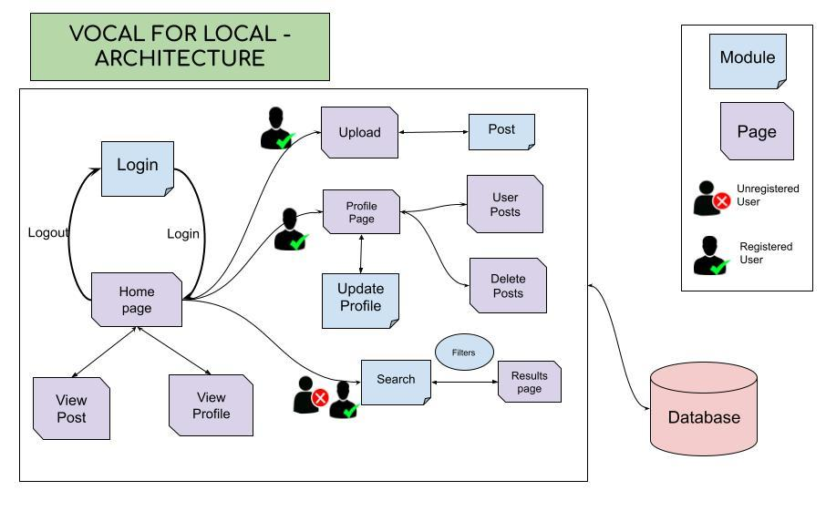
Mental Model:
- Login Module
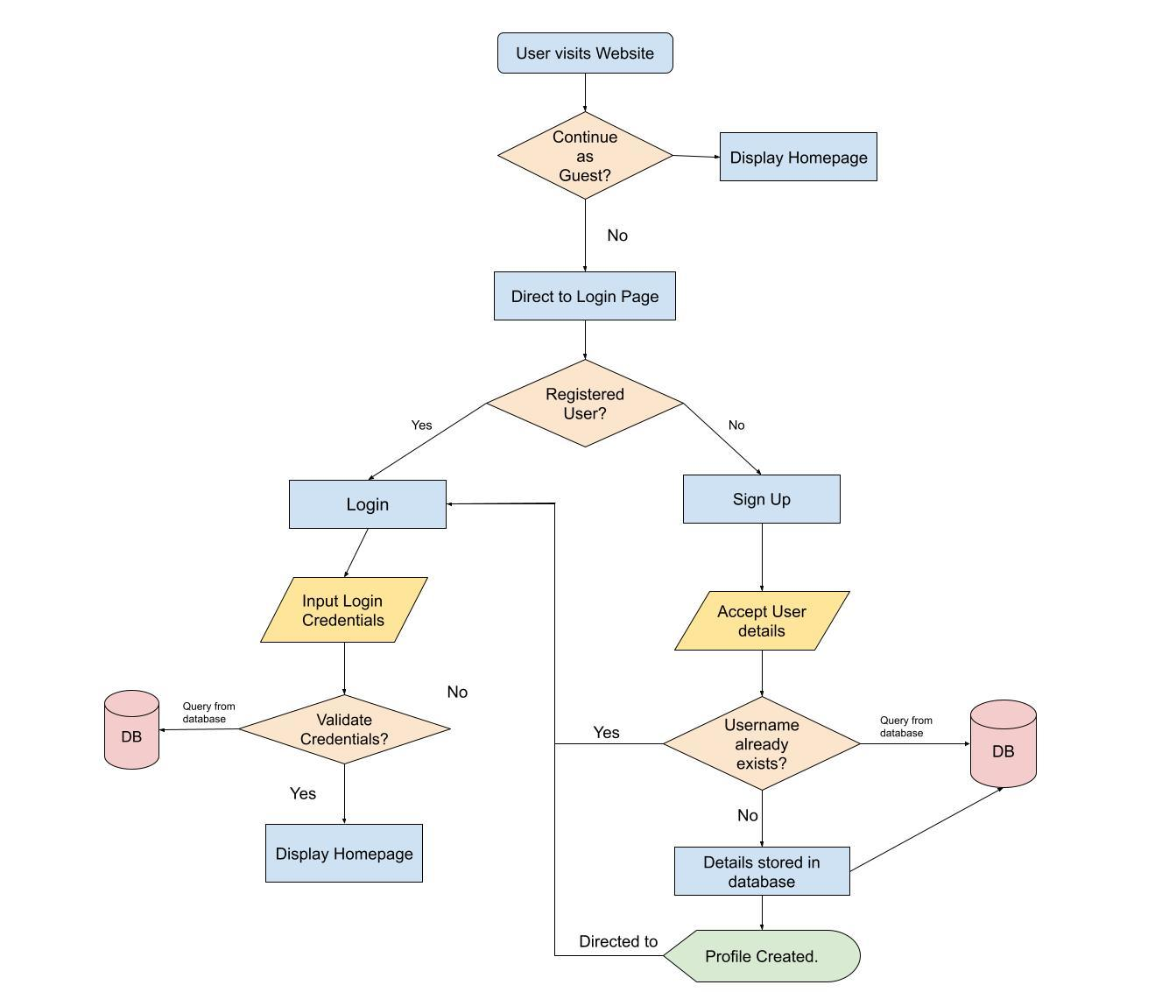

- Post Module

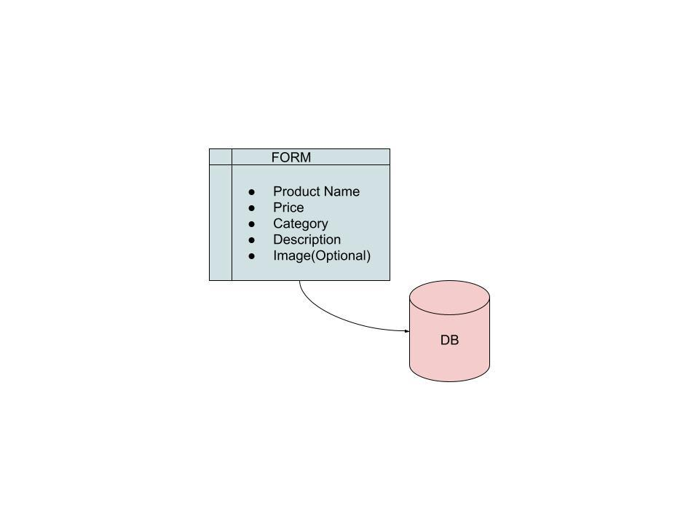

- Search Module

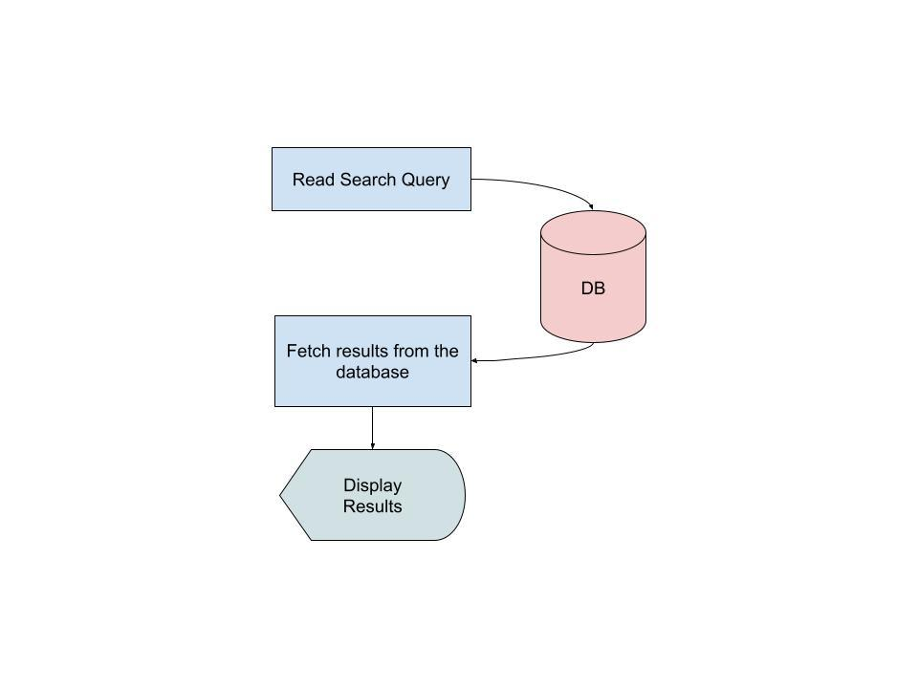

- Update Profile Module

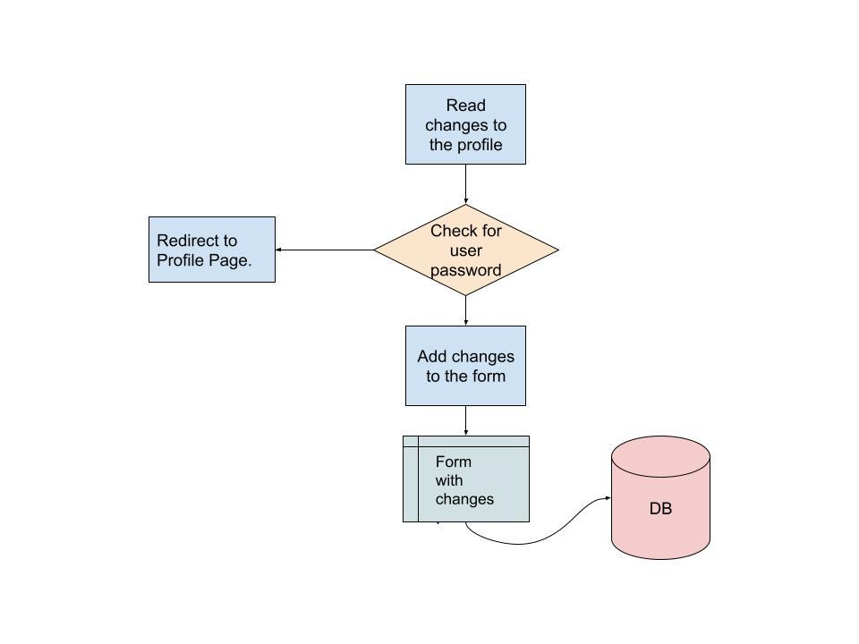

Implementation Model ( User Interfaces):

Home Page:
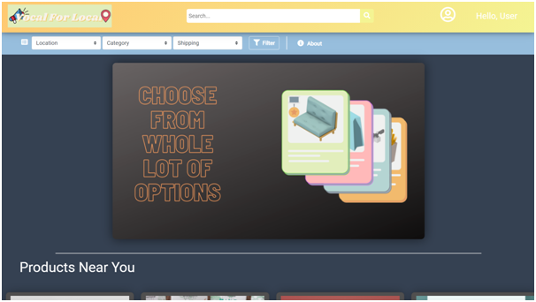

Navbar:
- VFL Logo: Redirects to the Home Page.
- Search: Text Field to search for products using name, description or businesses.
- Profile Icon: Presents Edit Profile and Logout options.

Filters:
- Location: Dropdown menu to filter products based on location.
- Category: Dropdown menu to filter products based on category.
- Shipping: Dropdown menu to filter products based on shipping availability.
- About: Redirects to About View page.

Main view:
- Display Slideshow
- Product Cards: Contains basic information about Product name, description, price, business owner.

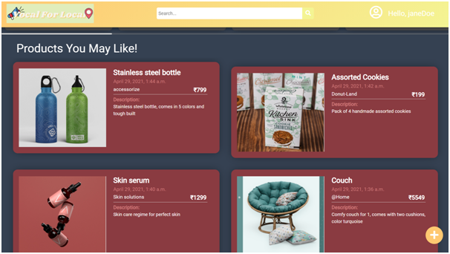
- Section on the home page which displays Product cards.
- Plus-Button: Redirects to product upload page.

Login Page:
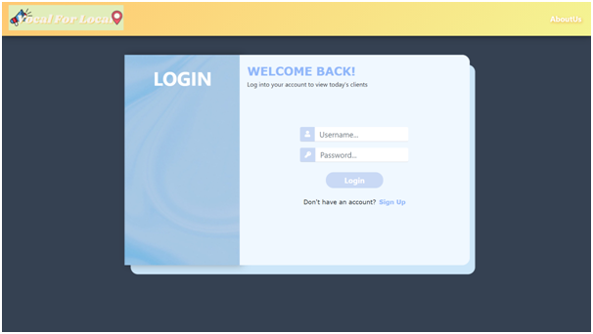
- Login button: To verify and redirect users to the home page.
- Sign up: To register a new user.

Register Page:
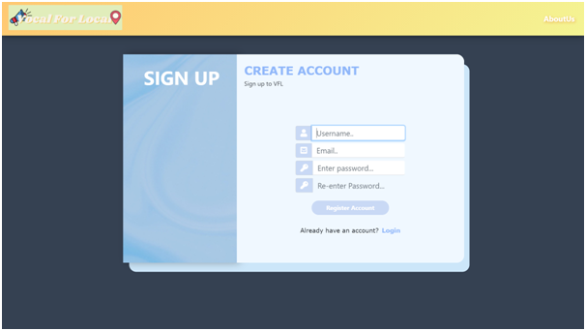
- Register account: Check user details and make an account.

Post Page:
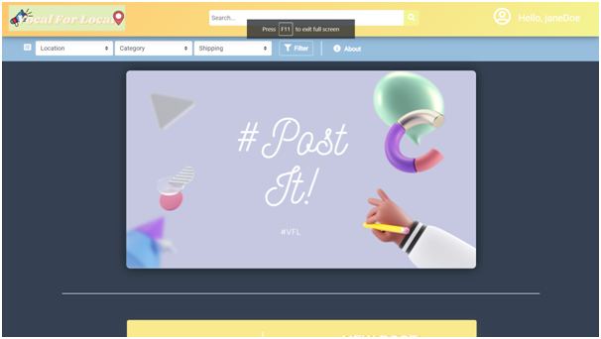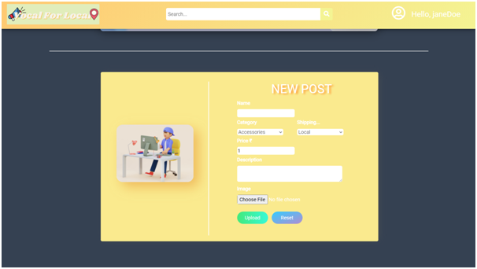
- Choose file: To Choose the respective image file from your device.
- Reset: Resets all fields of the form.
- Upload: List the product as a product card on main website and also the user profile

Profile Page:
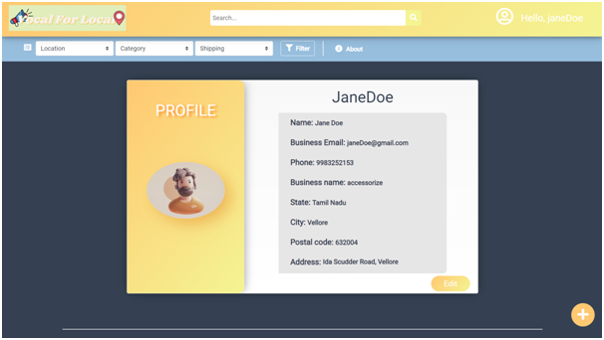
- Displays the profile of the user.
- Edit : To change the profile information.
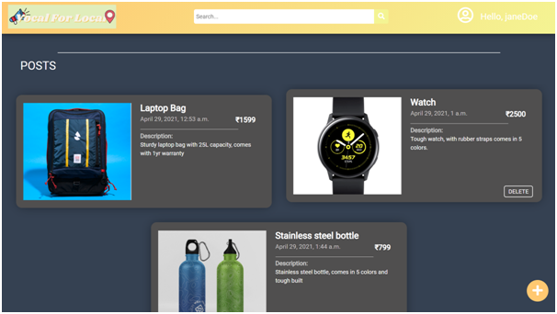
- This section shows all the posts made by a user/business.

Delete Post:
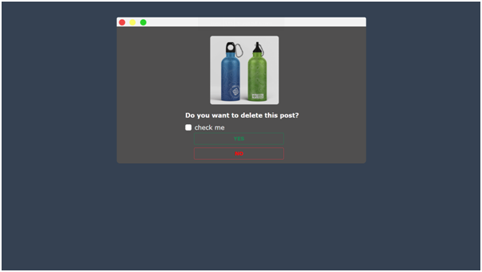
- Check box double confirmation for Post deletion.
Business Profile View:
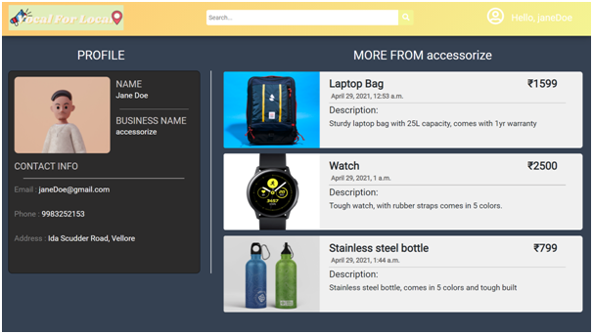
- Business details and other products offered are displayed here.

Business Product View:
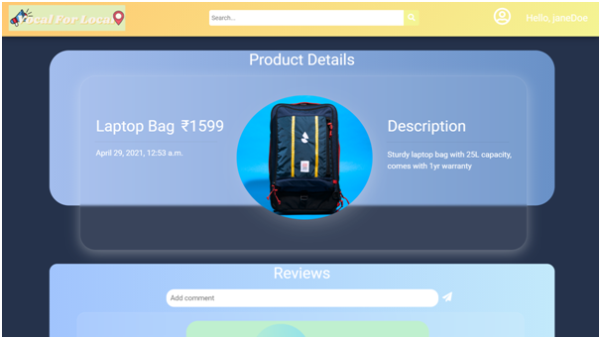
- Complete Product details and user comments shown here.
- Comments section: Registered users can give feedback about the products.

Search Result Page:
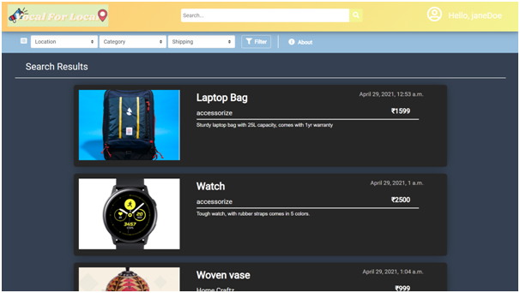
- Product cards: Displays basic information about the product. Will redirect to the Product view on click.
- Company Name of the product: Will redirect to the Business Profile view on click.
Filter Feature on Home Page:
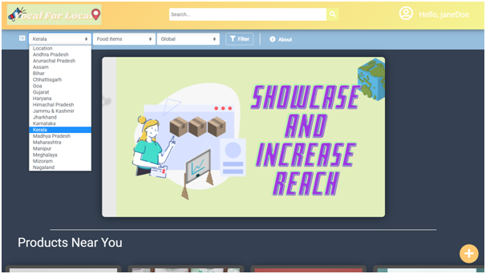
- The blue navigation bar on the top: Provides various filter options for searching products.

Filter Results:
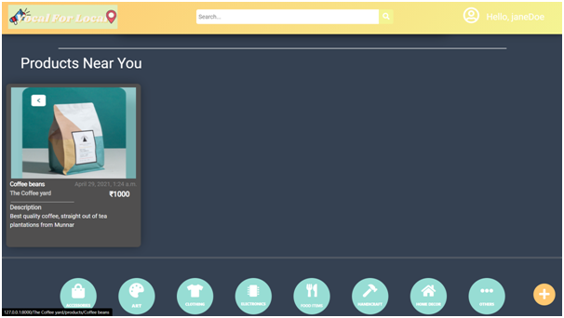
- Filters: In the bottom bar will filter out relevant searches.

Study and describe any one user interface tools
Now when I try to implement the UI with the help of an UI Interface tool, the design process becomes quite easier.

We will use the following UI tool:

Figma:
Figma is a web-based design tool with real-time collaboration.
A similar interface and all the same drawing tools as Sketch.
Prototyping. Figma has a clickable prototyping feature that’s similar to Craft + InVision.
Built-in Commenting. Anyone with the link can add comments anywhere on the design, similar to how commenting works in InVision. You can tag people in comments, mark comments as resolved, and even integrate with Slack.
Developer Handoff. Devs can get dimensions, styles, and download icons and images from the project URL. It’s like Zeplin, but again, you don’t have to sync your artboards whenever you update your designs.
Version Control. Figma includes version history for all collaborators. You can roll back to or fork from a previous state. This works like time machine on a Mac.
Multiplayer Collaboration. Multiple people can collaborate in real time. Similar to Freehand, we all see each other’s cursors on the screen and can draw things and make comments.
Liveshare. If you click on someone’s avatar, you get to see what they're seeing on their screen and follow their cursor around. This works just like InVision Liveshare (RIP Liveshare).
Components. Similar to Symbols in Sketch, but more flexible and easier to design with.
Constraints. Similar to Resizing in Sketch, but more intuitive.
Team Libraries. You can share and update collections of components across projects.

You can do a design review, make updates on the fly, and instantly get feedback on your changes. The time between iterations can go from days down to minutes because there is zero time wasted uploading or syncing screens, creating shared links, messaging people to look at the links, and so on.
Using frames like this is helpful for developers because a frame in Figma is akin to a container in HTML. When developers inspect the designs, they’ll be able to see UI elements nested in their respective containers, which means they’ll have a more accurate blueprint to refer to as they write their code.
With Figma, you can access and modify the properties of any layer in a component without detaching it from the master. The same thing goes for nested components. Now whenever you change a property of a layer in the master component, those changes will only get propagated to instances for which that property hasn’t already been overridden.
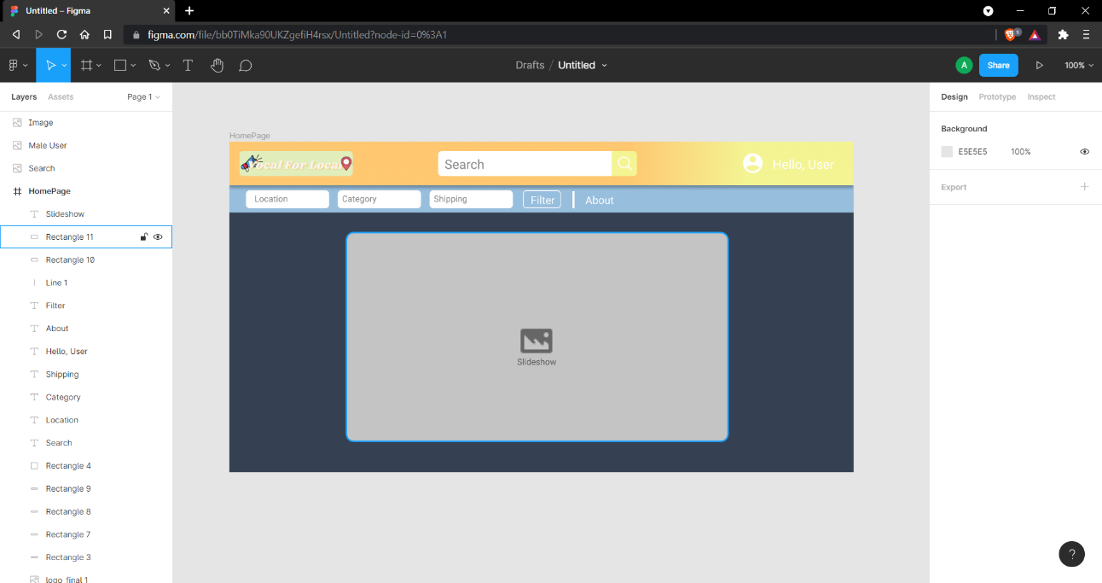
This HomePage UI design was created using Figma. Figma improved our productivity through its collaborative environment and easy to use tools.

Post Lab Descriptive Questions
- State various types of UI design tools.
Ans :-)
The tools used for the User Interface (UI) design of a software application i.e. it is part of software engineering to help UI designers to develop display screen design, design of important features, prototyping or blueprint for the software application user interface. It provides a replica or model of software application view screen design, prototype, or exchange of application features with the developer and tracking the product design workflow.

1. Sketch
It is a Photoshop-like tool, which is mostly preferred by the designer to design a User Interface (UI) for the software application. It is used to design UI for Mac Operating System (macOS) and provides the standard features like, art boards, symbols and mirroring effect, etc. It is a vector based drawing tool, allowing editing and manipulating photos, changing in style, layout, and size, reusable of elements using copy & paste inside the application UI.
2. Invision
It is a web based prototyping tool mainly used for UI design and is used in mac Operating System (macOS). It provides advanced prototypes, workflow status, drag and drop design components, adding of static images, adding animation pictures and uploading files. It makes a workflow bridge between designer and developer to design a better, faster and real time user interface (UI). It is also known as InVision Studio.
3. Adobe Xd
It is also known as Adobe Experience Design. It is a vector-based designing and prototyping tool used for user interface design. It supports macOS as well as Windows Operating systems. Adobe Xd provides screen designing and reusing, prototyping, developing wireframes, view designs in real-time, importing files and also integrating some Adobe based products/tools like Photoshop.
4. Figma
It is the first UI design tool that denotes design functionality, real-time collaboration, screen designing, real time mirroring of UI, prototyping, screen size change, gathering feedback, advanced animations, and reuse of design elements. It will support Web, macOS, Linux, Windows operating systems.
5. Flinto
It is an interactive prototyping tool used for user interface design of software applications. It offers some advanced features like, micro interactions between design, screen switching transitions, adding of video files by dragging video files or other video files like, GIF files into our user interface design, adding of sound effects and scrolling page effect, etc. It will be a suitable Mac Operating system only.
6. Balsamiq
It is the best Wireframing (Structural Level Design of Websites) tool, which makes links between designers, product owners, project managers, and developers. Here the different user interface elements are present in the UI library and as per our requirement; we choose the element and drag & drop it in the wireframe. So this is the easy way for the designer to ready the prototype of the UI. We can test it before handing it over to developers for a usability test. It is suitable for macOS as well as Windows operating system.
7. Origami Studio
It is a user interface design tool used by Facebook having multiple features like adding different rules and logics to the interactions, dynamic animation, screen visibility criteria, real time view, etc. It supports all types of operating systems like mac OS, Windows, Linux, and Web.
8. Principle
When we design a multi screen application or new animations then this tool is best for the UI design. It supports mac OS with extra features like, screen connections, art board creation, alignment, real time preview of UI and mirroring of screen and it does not support collaboration or teamwork.
9. Zeplin
It is not a UI design and prototyping tool but, it is used in the post design environment of the UI design prototype. It is an intermediate between the designer and developer to convert the UI into a developed application i.e. if we add the designed user interface to Zeplin then it converts into developer environment to develop the project. It will support the Mac OS, Windows, Web.

- Explain the UI design Principles
Ans :-)
The principles of User Interface Design are as follows:
- Minimize actions − Minimize action means steps per screen. The tasks and actions are streamlined so that they can be done in as few steps as possible. The interface should be designed keeping in mind to maintain the steps as few as possible for performing any tasks.
- Simplicity − The user interface should not be complex. It should always be designed simple and elegant.
- Consistent − The user interface should be consistent. The design should be consistent. Increasing consistency increases the familiarity, and hence increases the usability.
- Proving useful feedback − The user should be provided with feedback for every action. This keeps the user informed and helps them to know whether some action was successful or not.
- Clarity − Content should provide the user with clarity. There should not be anything which confuses the user, as it becomes an obstacle for the user in interacting with the product.

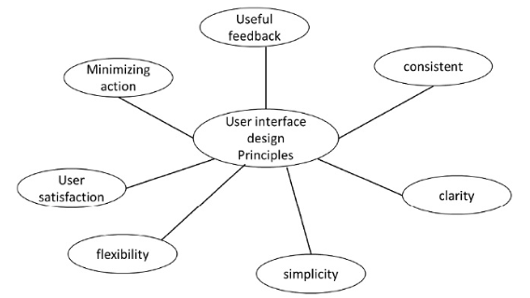

- What do you understand by a good interface and a bad interface
Ans :-)
Generally, an interface acts as a shared boundary across two or more separate components of a computer system that are used to exchange information. Those exchanges can be between software, computer hardware, peripheral devices, etc.
Now let us discuss the good interface and bad interface.
A good interface design is user friendly. This is because it is easy to navigate, easy to use, easy to understand, interactive and effective. A good design should always be clear and user centric.

Features −
- Clear
- Consistent
- Simple
- User controlled
- Forgiving
- Provide feedback

Some of the Examples of Good Interface design −
- Elastic Scrolling on iOS
- Dropbox’s responsive colour system.
- Pinterest’s waterfall effect

A bad interface design is confusing. This is because it is erroneous, difficult to navigate, sluggish, unresponsive, inconsistent and misleading.

Examples of bad interface design
A few examples of bad User interface along with the respective solutions are as follows −
- Plagiarized design as well as content
Solution − Make sure the design and content is original.
- Too many colours and lack of contrast
Solution − Choose colours for your website wisely. Using too many colours can confuse the user and can affect their interest to view the entire website.
- Website is static
Solution − Use dynamic technologies like Angular, React to create dynamic responsive websites.
- Unnecessary Animation
Solution − Keep it simple and elegant. Users may not like unnecessary animations and the effort required to remove them off the screen.
- Not having enough tooltips
Solution − Tooltips are useful when the users are not very proficient in using the application. Tooltips provide additional information about an icon or button or link when the cursor is moved over it.

